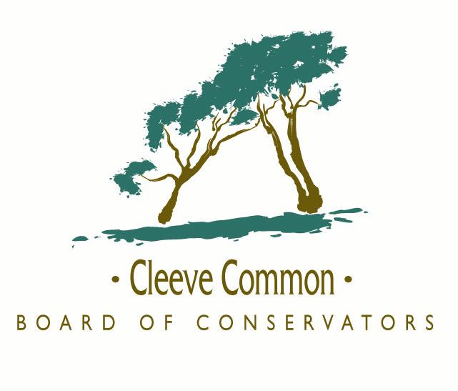
The Dewpond

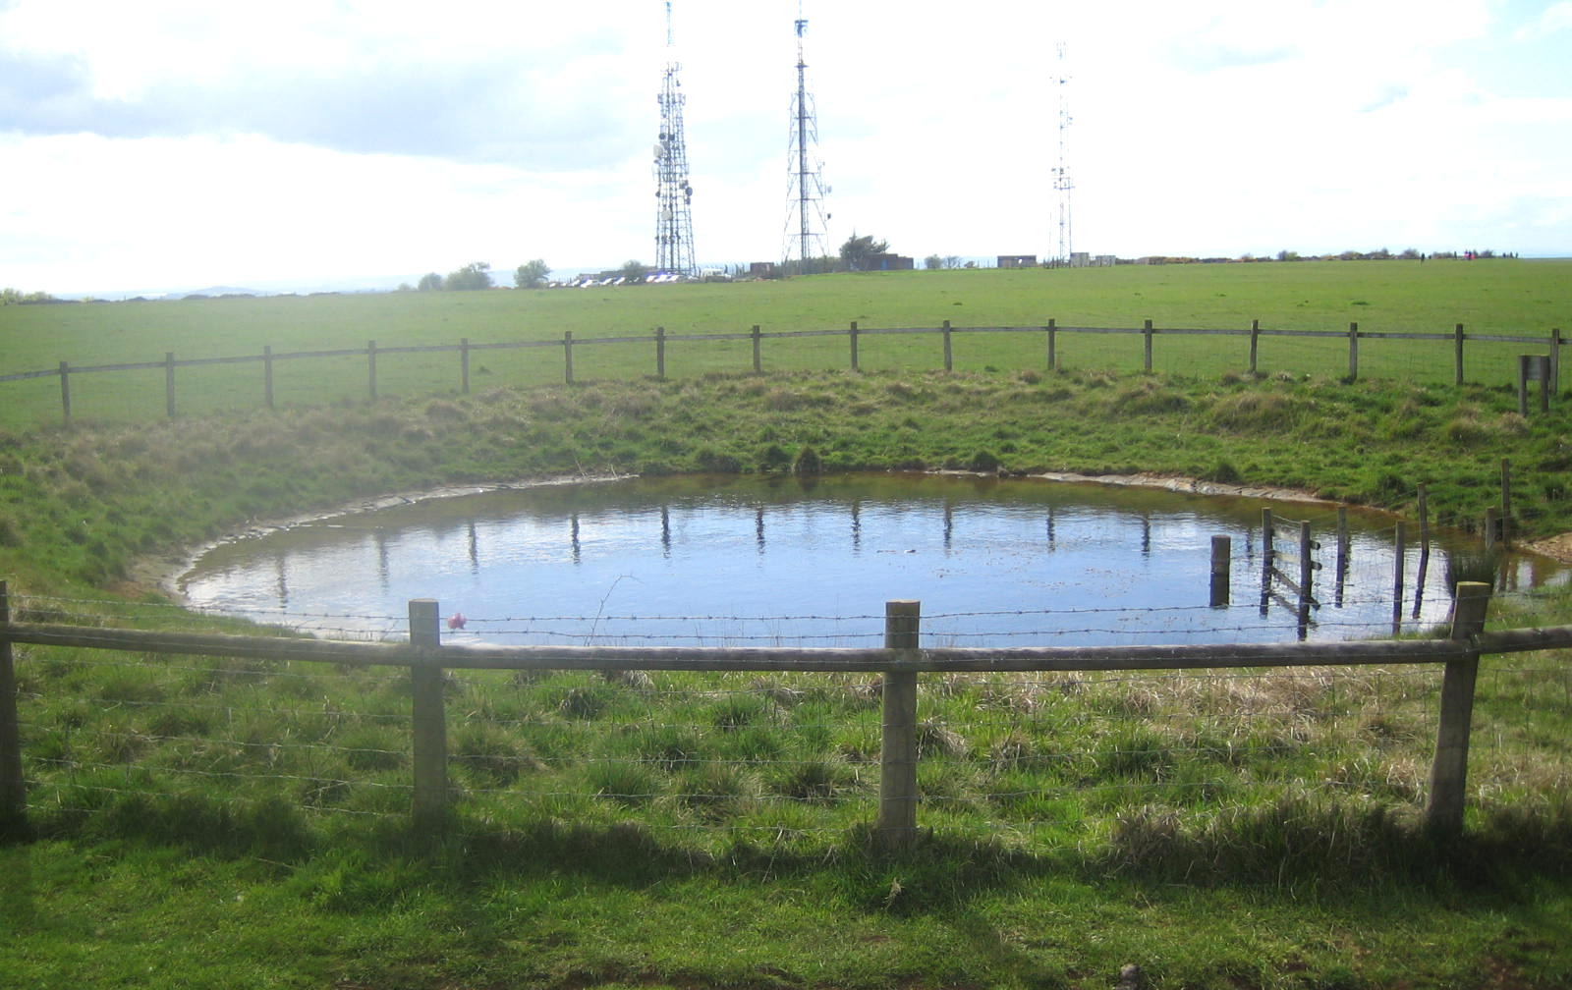
For a long while there was a large hole in the ground on Cleeve Common near the radio masts. It looked rather like a bomb crater, indeed some people mistakenly called it that. It is actually a historic dewpond, which was restored in the year 2000 as an experiment in a traditional way of providing drinking water for grazing animals.

Mystery and magic

The term ‘dewpond’ is used to describe a pond constructed in limestone uplands where there is no running water supply. They are particularly prevalent in the South Downs and Chilterns, but there are many examples in the Cotswolds too. The art of making dewponds may stretch back as far as Neolithic times and lasted until the Second World War, when the increasing availability of piped water and fears over TB in cattle put an end to their use.

Dewponds are also known as cloud ponds, mist ponds, fog ponds or (more prosaically) sheep ponds and have over the centuries held an air of mystery, even magic. How can a depression in the ground be full of water even in a dry summer?

This question has been hotly debated in the past and there were many experiments in the early 19th century to determine if dew really was the source of water in such ponds. The true explanation has little to do with either dew or magic. A large surface area and careful siting ensures the dewpond catches rainwater and run-off from the surrounding soil. A clay lining, often reinforced with straw, retains the collected water.

However an air of mystery and a name to catch the imagination suited the purveyors of dewponds in the past. For instance, “the art of genuine Dew Pond making has been successfully practised by my forefathers for generations, the secret process having been handed down from father to son for over 250 years”. This comes from an advert in 1938 by Mr L J Smith of Dunstable. The name of the Smith family crops up frequently as constructors of dewponds.

Cleeve Common dewpond

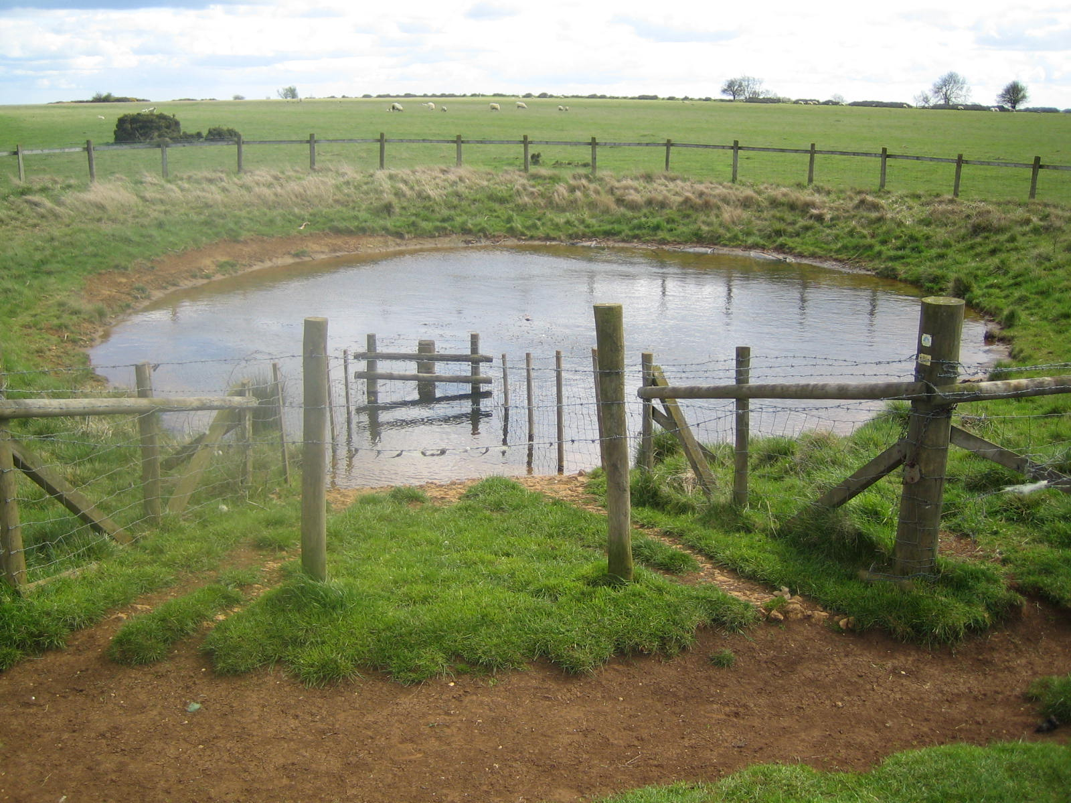
The dewpond which has been restored on Cleeve Common is some 70 feet in diameter and 6 feet deep. It was originally lined with clay, which probably came from the lower slopes of Cleeve Hill. It is, however, difficult and very time consuming to apply clay, which cracks when dry. Modern technology has lent a hand in the restoration project in that a butyl sheet liner is now used to keep the water in.

There is a fence round the pond in the shape of a cake with a slice taken out. This missing wedge is a stone ramp for animals to walk down to drink the water without damaging the lining – or slipping into the pond. The lining is dug into the sides of the pond a little below ground level, to allow water running through the topsoil to drain into the pond.

Little is known about this particular dewpond. It could be as old as the nearby Iron Age hill fort above Nutterswood or as recent as the 20th century. It lies on the route of an old drovers’ road across the hill and would have been useful in watering cattle on the move. Animals grazing the Common must have drunk there too – there is no spring water on this part of the hill. It may even have been used to water racehorses during the heydays of racing on the Common from 1818 to 1842.

Volunteer diggers

Most of the work was carried out by volunteers from the Cotswold Voluntary Warden Service, who braved wind, rain and the endless sticky mud of the clay-lined hollow to recreate this historic landmark. Contractor support helped with the initial excavation and the lining. The project was sponsored by Cleeve Common Board of Conservators.

But does it work?

The Cleeve Common dewpond has provided a source of water not only for sheep, but also for wildlife on the Hill and is visited by a wide range of birds. Cattle have been kept out for fear of damaging the lining.

So far, it has never dried up, even in prolonged dry spells. There was, however, one occasion when it had to be pumped almost dry by the local Fire Brigade – who were called in to rescue some goldfish that had been dumped in the pond!

How to find the dewpond

From the gate on to the Common by the radio masts, bear half right. The pond is about 250 yards away, surrounded by a wooden fence.

© Cleeve Common Board of Conservators 2000, updated 2007

